**MODUL 4 PRAKTIKUM PWD**

**Nama : Arif Nur Faudin  
NIM : L200160099  
Kelas : B**

1. **Percobaan 1**

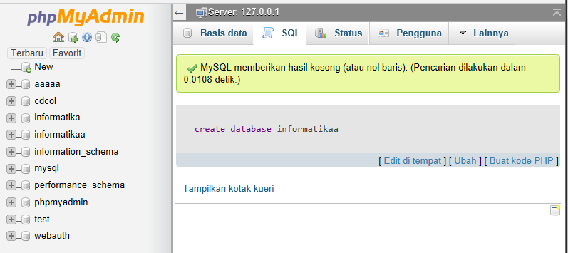

1. **Percobaan 2**

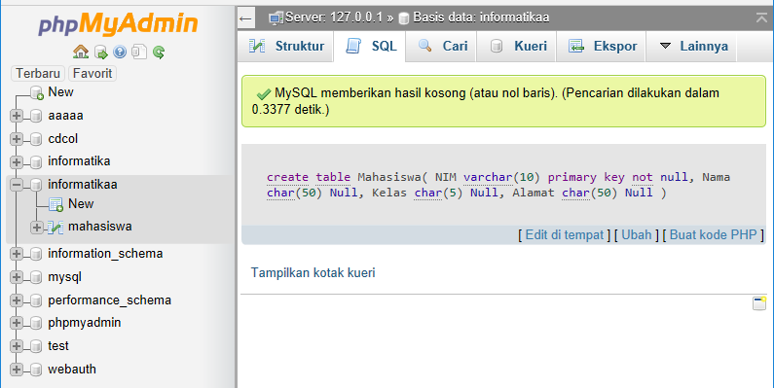

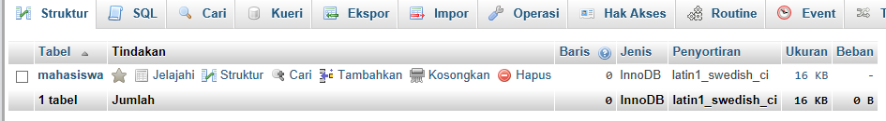

1. **Percobaan 3**

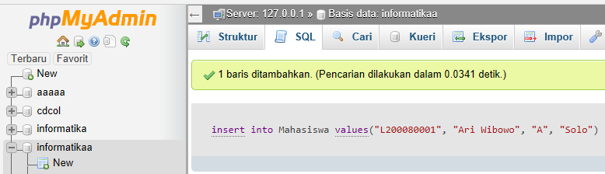

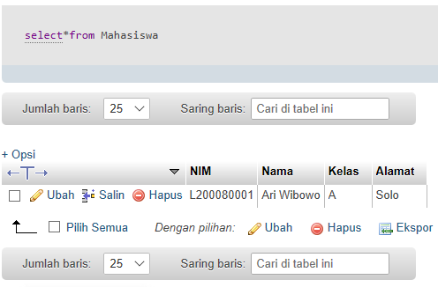

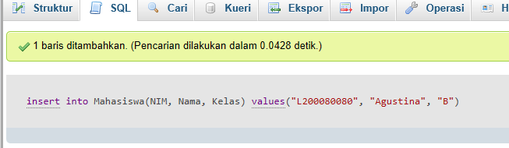

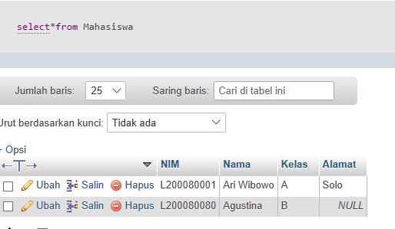

1. **Percobaan 4**

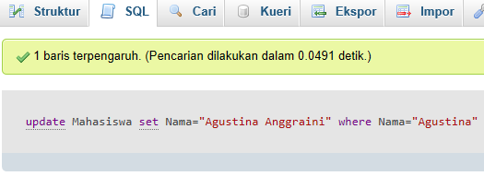

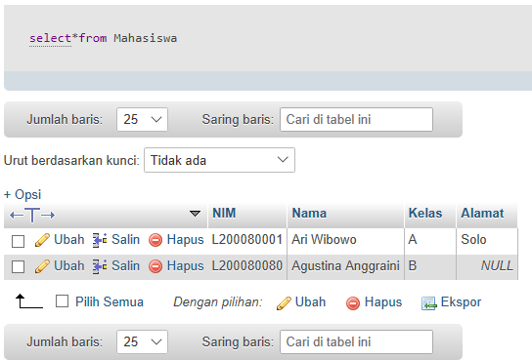

1. **Percobaan 5**

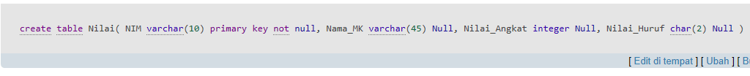

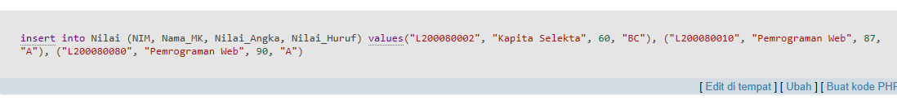

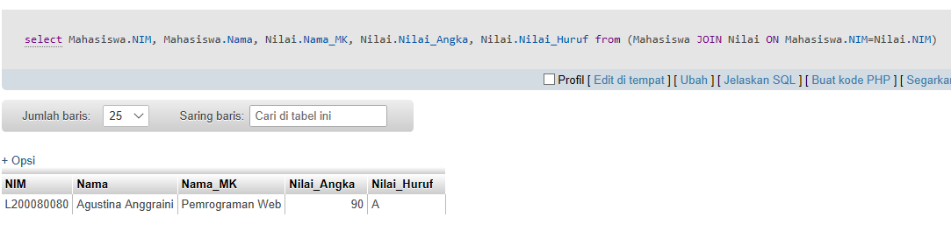

1. **Percobaan 6**

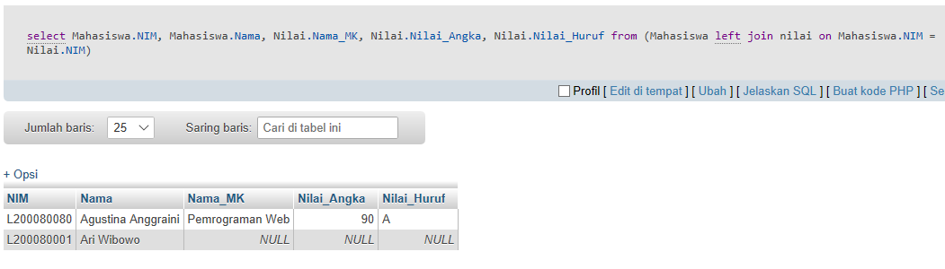

1. **Percobaan 7**

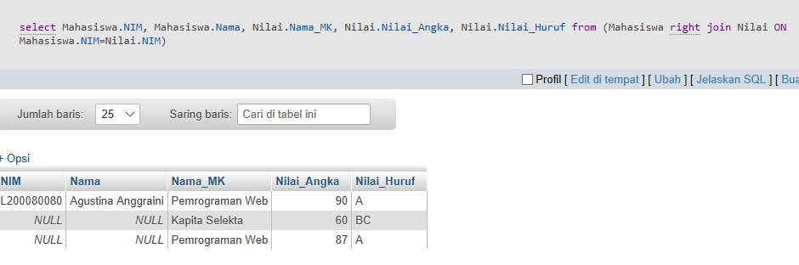

1. **Percobaan 8**

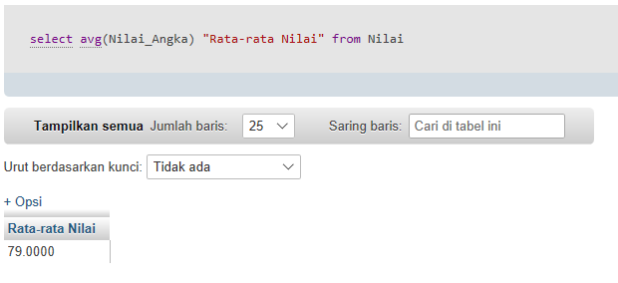

1. **Percobaan 9**

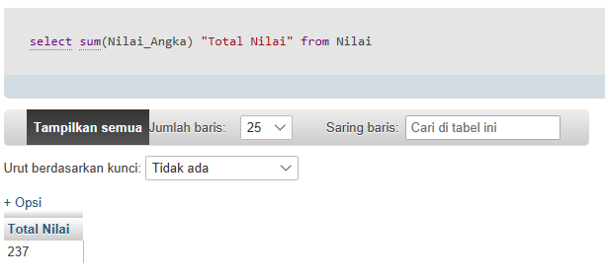

1. **Percobaan 10**

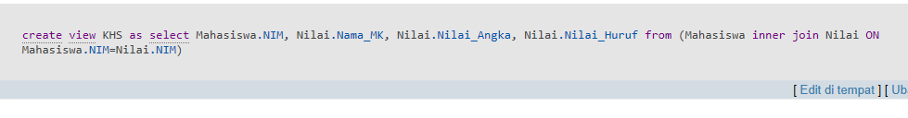

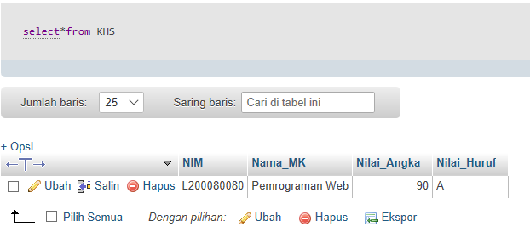

**Tugas**

1. **Fungsi**
2. Select : to show the containt of the table
3. Join : For making relaiton between two tables or more who has relation / connection
4. Left Join : For showing the data who has not relation
5. Right Join : For showing the data who has not relation but that data will have value Null
6. AVG : For calculating average in one coloumn of table
7. SUM : For summarizing in one coloumn of table
8. **Syntax**

**update Mahasiswa set Alamat = “Sragen” where NIM = “L20008080”;**